**OTHER IMPORTANT TAGS**

1. <br> : It is used to add a line break in between paragraphs or content.
2. <hr> : It is used to add a horizontal rule.
3. <div> : Its used to divide the code into different sections.
4. <span> : It is an inline container used to mark up a part of a text, or a part of a document.

**FORMATTING TAGS**

* <b> - Bold text
* <strong> - Important text
* <i> - Italic text
* <em> - Emphasized text
* <mark> - Marked text
* <small> - Smaller text
* <del> - Deleted text
* <ins> - Inserted text
* <sub> - Subscript text
* <sup> - Superscript text

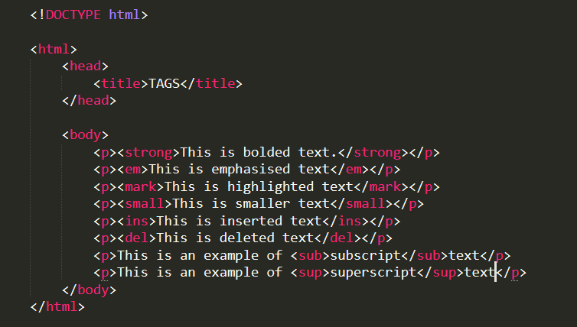

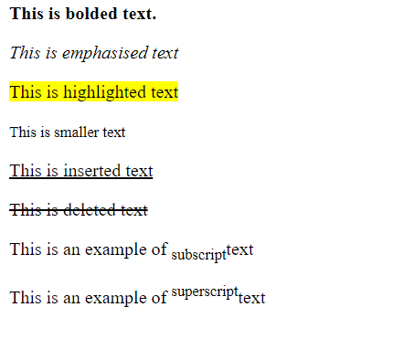

**HTML COMMENTS**

Comments are used for documentation and are only for extra information and code debugging.

Anything written within the comments will not be read by the browser and will not be displayed in the web page.

Html comments are represented as **<!-- Write your comment -->**